Name: ___________________________________________________________________ AM MID PM

**Due January 31st** 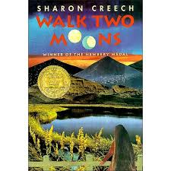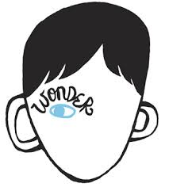

Genre Study Project

**Realistic Fiction**

**Realistic Fiction stories feature believable characters and events. There are no elements of fantasy or science fiction. The stories seem like they could happen in real life. The setting is usually in the present time of when the novel was written, and is in a real place in the world or a fictional place that seems like a real place. Answer the questions using details from your novel. Write at least 2 full sentences per answer.**

**Book Title:** _____________________________________________________

**Author:** __________________________________________________________

**Who is the main character? Describe their personality. Use details of characterization from the novel.**

________________________________________________________________________________________

________________________________________________________________________________________

________________________________________________________________________________________

________________________________________________________________________________________

**What is the main conflict in the novel, and how is it resolved?**

________________________________________________________________________________________

________________________________________________________________________________________

________________________________________________________________________________________

________________________________________________________________________________________

**What is a theme of this novel? What are some details from the novel that contribute to the theme?**

Theme statement: ________________________________________________________________________

Details: _________________________________________________________________________________

________________________________________________________________________________________

________________________________________________________________________________________

→

**Complete the plot diagram with key events from the novel.**

**Exposition**

**Rising Action**

**Conflict**

**Climax**

**Resolution**

**Falling Action**

**Illustrate your favorite scene or character.**

|  |
| --- |
|  |

**Due January 31st**